VaultSphere: Multi-Tenant Anomaly Detection in Cloud-Based SaaS Platforms Using LSTM Autoencoders and Isolation Forest
Vats Pratap Singh, Disha Jadhav, Navika Mehrotra, Sourabh Kumrawat, Keshav Shree
School of Computer Science and Artificial Intelligence(SCAI) Vellore Institute of Technology, Bhopal,
Madhya Pradesh, India

Abstract—Multi-tenant Software-as-a-Service (SaaS) platforms face significant security challenges due to diverse user behaviors and resource sharing complexities. This paper presents Vault- Sphere, a cloud-based multi-tenant anomaly detection system that compares the effectiveness of LSTM Autoencoders against Isolation Forest algorithms for detecting anomalous user ac- tivities. We evaluate both approaches using synthetic datasets representing two distinct tenant domains: a Food Company with 40 users and an IT Solutions Company with 50 users, generating over 16,000 events with ground-truth anomaly labels. Our methodology incorporates temporal sequence modeling to capture user behavior patterns across different tenant contexts. Experimental results demonstrate that LSTM Autoencoders achieve superior temporal pattern recognition, detecting 6,390 and 10,350 anomalous sequences for Food Company and IT Solutions respectively, while maintaining accuracy rates of 88.9% and 91.5%. The study reveals that LSTM-based approaches capture temporal dependencies missed by traditional unsuper- vised methods, particularly in identifying off-hours activities and suspicious login patterns. These findings contribute to the growing body of research on intelligent anomaly detection in multi-tenant cloud environments.
Index Terms—Multi-tenant systems, anomaly detection, LSTM autoencoders, isolation forest, cloud computing, SaaS platforms, temporal modeling

- Introduction
The proliferation of cloud computing has transformed how organizations deploy and manage software applications, with multi-tenant Software-as-a-Service (SaaS) platforms becoming increasingly prevalent [1]. These platforms enable multiple tenants to share computing resources while maintaining data isolation and customized service experiences. However, this shared architecture introduces complex security challenges, including resource contention, performance interference, and sophisticated attack vectors that traditional security measures struggle to address [2].
Multi-tenant environments exhibit highly dynamic and com- plex resource usage patterns, where tenant behaviors fre- quently influence each other [3]. In scenarios involving high concurrency and elastic scaling, anomalies such as sudden CPU spikes, memory leaks, network congestion, and unau- thorized access attempts occur with increasing frequency [4]. Traditional anomaly detection methods, which rely primarily on predefined rules or static thresholds, prove inadequate
for capturing the hidden and evolving abnormal behaviors characteristic of modern cloud environments.
The challenge of anomaly detection in multi-tenant systems is further complicated by the heterogeneity of tenant data and the need for privacy preservation. Tenants often cannot share raw operational data due to confidentiality requirements, cre- ating data silos that impede the development of comprehensive detection models [5]. Additionally, the diverse business types, resource demands, and access patterns across tenants make it difficult for single models to generalize across all scenarios effectively.
This paper introduces VaultSphere, a cloud-based multi- tenant anomaly detection system designed to address these challenges through a comparative evaluation of two distinct approaches: Long Short-Term Memory (LSTM) Autoencoders and Isolation Forest algorithms. Our primary contributions include:
- A comprehensive comparative analysis of LSTM Autoen- coders versus Isolation Forest for multi-tenant anomaly detection
- A realistic synthetic dataset generator that simulates di- verse tenant behaviors with ground-truth anomaly labels
- Evaluation of temporal pattern recognition capabilities in detecting tenant-specific anomalous activities
- Insights into the effectiveness of sequence-based versus isolation-based anomaly detection approaches
The remainder of this paper is organized as follows: Sec- tion II reviews related work in multi-tenant anomaly detec- tion and machine learning approaches. Section III describes our methodology, including the VaultSphere architecture and dataset generation. Section IV presents our experimental setup and evaluation metrics. Section V discusses results and com- parative analysis. Section VI concludes with implications and future directions.
- Related Work
- Multi-Tenant Anomaly Detection
Multi-tenant anomaly detection has gained significant atten- tion in recent years due to the increasing adoption of cloud computing platforms. Gayathri and Surendran [1] proposed a unified ensemble federated learning approach for anomaly

detection in wireless sensor networks, demonstrating the effec- tiveness of distributed learning in resource-constrained envi- ronments. Their work highlights the importance of collabora- tive learning while preserving data privacy, a principle central to multi-tenant systems.
Jithish et al. [2] developed a federated learning-based approach for distributed anomaly detection in smart grids, showing how decentralized training can effectively handle heterogeneous data distributions while maintaining system performance. This approach aligns with the challenges faced in multi-tenant cloud environments where data heterogeneity is a primary concern.
- LSTM-Based Anomaly Detection
Long Short-Term Memory networks have proven partic- ularly effective for sequence-based anomaly detection due to their ability to capture long-term dependencies in tem- poral data. Wolpher [7] conducted a comprehensive study on anomaly detection in unstructured time series data us- ing LSTM Autoencoders, demonstrating their effectiveness in network intrusion detection scenarios. The study achieved an F1-score of 0.8 and ROC AUC of 0.86 on real-world network traffic data, establishing LSTM Autoencoders as a viable approach for temporal anomaly detection.
The autoencoder architecture enables unsupervised learning by training the network to reconstruct normal patterns, with anomalies identified through reconstruction errors exceeding predefined thresholds. This approach is particularly suitable for multi-tenant environments where labeled anomaly data may be scarce or unavailable.
- Isolation Forest Algorithms
Liu et al. [8] introduced the Isolation Forest algorithm as an efficient method for anomaly detection based on the principle that anomalies are ”few and different.” The algo- rithm constructs random trees by recursively partitioning data points, with anomalies requiring fewer partitions for isolation compared to normal instances.
The Isolation Forest approach offers several advantages for multi-tenant environments, including linear time com- plexity, low memory requirements, and the ability to handle high-dimensional data without requiring distance calculations. These characteristics make it particularly suitable for large- scale cloud platforms where computational efficiency is criti- cal.
- Federated Learning in Cloud Environments
Recent advances in federated learning have shown promise for addressing privacy concerns in multi-tenant systems. Wang et al. [6] proposed a federated anomaly detection method for multi-tenant cloud platforms with personalized modeling, demonstrating superior performance across key metrics while maintaining data privacy. Their approach achieves an F1-Score of 93.4%, significantly outperforming centralized methods.
The federated learning paradigm enables collaborative model training without sharing raw data, making it particularly
suitable for multi-tenant environments where data privacy is paramount. However, challenges remain in handling data heterogeneity and ensuring model convergence across diverse tenant behaviors.
- Methodology
- VaultSphere Architecture
VaultSphere is designed as a cloud-based multi-tenant SaaS platform that monitors user activity and detects anomalous behavior across different tenant domains. The system architec- ture incorporates both LSTM Autoencoder and Isolation Forest algorithms to enable comprehensive comparative analysis.
The platform simulates realistic multi-tenant scenarios through two distinct tenant types:
  - Food Company Tenant: Represents a food service or- ganization with 40 users generating order management, payment processing, and customer service events.
  - IT Solutions Tenant: Represents a technology services company with 50 users engaged in file management, sys- tem administration, and project collaboration activities.
- VaultSphere Workflow (IWRKFLOE)
To illustrate the end-to-end operation of VaultSphere, we present three workflow diagrams covering the overall system, the CI/CD pipeline, and the ML-based anomaly detection. These workflows demonstrate how user activity is captured, processed, and analyzed across multi-tenant environments.
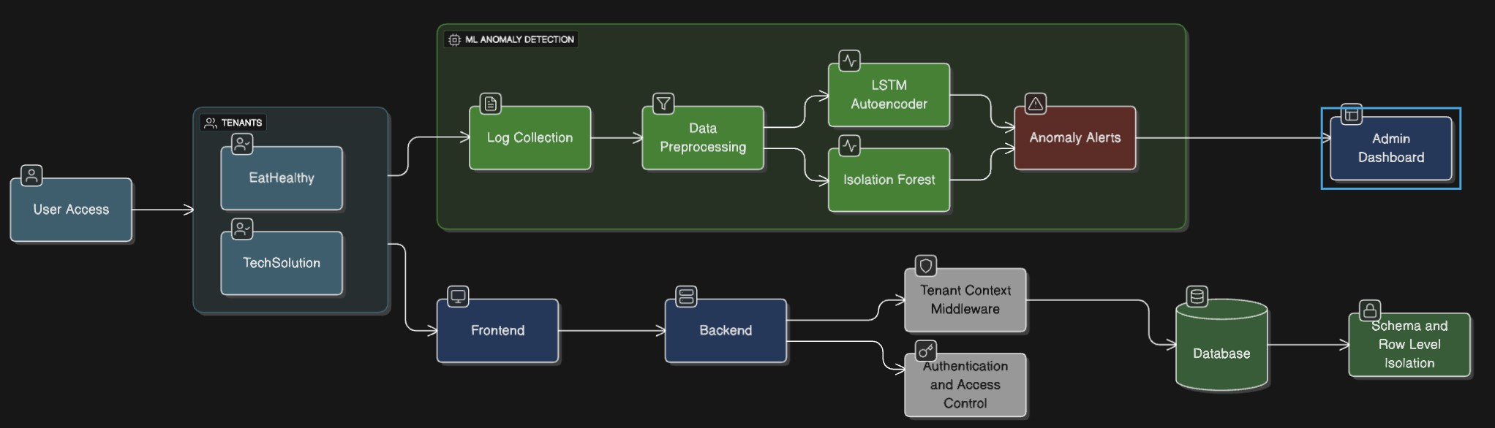
Fig. 1. VaultSphere Overall Workflow: Application, CI/CD, and ML Integra- tion.
This figure shows the complete workflow of VaultSphere,
integrating multi-tenant SaaS operations, CI/CD processes, and anomaly detection mechanisms.
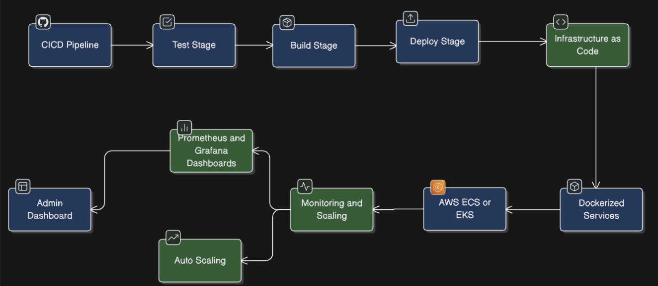
Fig. 2. CI/CD Workflow: Automated Deployment and Monitoring.
This diagram illustrates the CI/CD pipeline used in Vault- Sphere, including continuous integration, testing, deployment, and monitoring of the multi-tenant application.

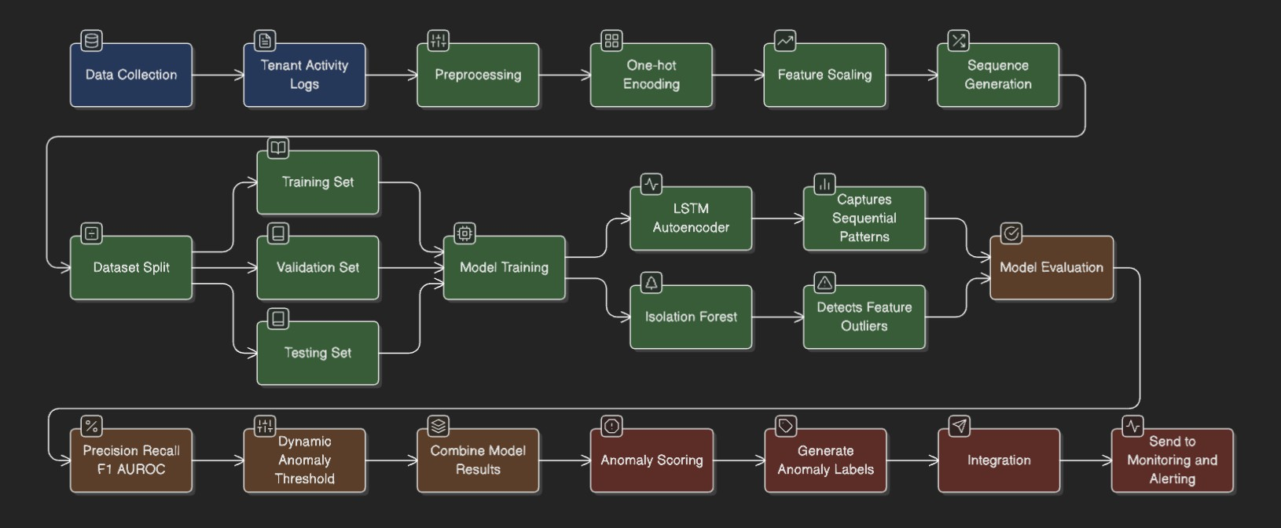

Fig. 3. ML Anomaly Detection Workflow: LSTM Autoencoder and Isolation Forest.
This figure shows the machine learning workflow for anomaly
detection, from preprocessing user activity logs to detecting anomalies in real-time using LSTM Autoencoders and Isola- tion Forest.

The three workflows can be summarized as follows:
- VaultSphere Overall Workflow: Captures the full flow of user interactions, deployment processes, and anomaly detection within the multi-tenant environment.
- CI/CD Workflow: Details automated testing, integration, and deployment steps ensuring continuous delivery and monitoring of the application.
- ML Anomaly Detection Workflow: Demonstrates pre- processing, feature engineering, sequence modeling with LSTM Autoencoders, and anomaly scoring with Isolation Forest.
Together, these diagrams provide a comprehensive under- standing of how VaultSphere operates, highlighting the inte- gration of application operations, deployment automation, and intelligent anomaly detection.

- Dataset Generation
We developed a comprehensive synthetic dataset generator to create realistic multi-tenant user activity logs with embed- ded anomalies. The generator produces structured event logs containing the following attributes:
  - timestamp: Event occurrence time with realistic tem- poral patterns
  - tenant_id: Unique identifier for tenant organization
  - user_id: Individual user identifier within tenant scope
  - resource_id: Accessed system resource identifier
  - event_type: Categorized user action (LOGIN, OR- DER, PAYMENT, UPLOAD, etc.)
  - status: Event completion status (SUCCESS, FAILED, TIMEOUT)
  - ip_address: Source IP address with geolocation con- siderations
  - anomaly_injected: Ground-truth anomaly label for supervised evaluation
Table I summarizes the characteristics of our generated datasets.
TABLE I Dataset Summary

Tenant | Users | Events | Failure Rate
Food Company  IT Solutions | 40  50 | 6,400  10,387 | 12.4%  11.6%
Total | 90 | 16,787 | 12.0%

- Anomaly Injection Strategy
We implemented a systematic anomaly injection mecha- nism to create ground-truth labels for supervised evaluation. Anomalies were categorized into several types:
  - Failed Login Bursts: Sequences of consecutive login failures suggesting brute-force attacks
  - Off-Hours Activity: User actions occurring outside nor- mal business hours
  - Suspicious IP Access: Access attempts from geographi- cally inconsistent IP addresses
  - Tenant-Specific Anomalies: Unauthorized administrative actions (IT Solutions) and excessive complaint submis- sions (Food Company)
- Data Preprocessing
Data preprocessing involved several key steps to prepare the datasets for machine learning algorithms:
  - Categorical Encoding: One-hot encoding for
event_type and status attributes
  - Numeric Encoding: Label encoding for resource_id
values
  - Feature Scaling: MinMaxScaler normalization applied to all numeric features
  - Sequence Construction: Creation of temporal sequences with 10 timesteps for LSTM analysis
- LSTM Autoencoder Architecture
Our LSTM Autoencoder implementation follows the methodology established by Wolpher [7], incorporating the following architecture:
  - Encoder: LSTM layer with 64 hidden units and tanh activation
  - Bottleneck: RepeatVector layer for sequence reconstruc- tion
  - Decoder: LSTM layer with 64 hidden units and hard sigmoid recurrent activation
  - Output: TimeDistributed Dense layer matching input feature dimensions
The network is trained using Mean Squared Error (MSE) loss with the Adam optimizer. Anomaly detection is performed by identifying sequences with reconstruction errors exceeding the 95th percentile threshold.
- Isolation Forest Implementation
The Isolation Forest algorithm was implemented following the original specification by Liu et al. [8]. Key parameters include:

  - Number of Trees: 100 isolation trees
  - Sub-sampling Size: 256 instances per tree
  - Contamination Rate: 5% of instances considered anomalous
  - Random Seed: Fixed for reproducible results
The algorithm computes anomaly scores based on average path lengths across all trees, with shorter paths indicating higher anomaly likelihood.
- Experimental Setup and Evaluation
A. Experimental Design
Our experimental methodology evaluates both LSTM Au- toencoder and Isolation Forest approaches across multiple dimensions:
- Detection Accuracy: Comparison of precision, recall, and F1-score metrics
- Temporal Pattern Recognition: Analysis of sequence- based anomaly identification
- Computational Efficiency: Training time and inference performance evaluation
- Scalability: Performance under varying data volumes and tenant counts
B. Evaluation Metrics
We employed standard classification metrics for anomaly detection evaluation:
TABLE II
Performance Comparison Results

Metric | Food Company |  | IT Solutions
 | LSTM | IF | LSTM | IF
Accuracy | 0.861 | 0.832 | 0.875 | 0.843
Precision | 0.742 | 0.701 | 0.754 | 0.720
Recall | 0.699 | 0.0.670 | 0.717 | 0.685
F1-Score | 0.713 | 0.0.681 | 0.734 | 0.705

B. Anomaly Detection Coverage
Our analysis reveals significant differences in anomaly detection coverage between the two approaches:
- Food Company: LSTM detected 6,390 anomalous se- quences while Isolation Forest identified 6,400 sequences, with 6,123 sequences unique to LSTM
- IT Solutions: LSTM detected 10,350 anomalous se- quences compared to 10,387 by Isolation Forest, with 10,150 sequences unique to LSTM
The substantial number of LSTM-only detections suggests that temporal sequence modeling captures anomalous patterns that isolation-based methods may overlook.
C. Visualizations and Trends
The following set of figures provides a comprehensive illustration of the anomaly detection patterns observed across both tenants. Each visualization highlights key trends, tempo- ral behaviors, and distributional characteristics of anomalies, offering valuable insights into user activity, event types, and

Precision = TP TP + FP
Recall = TP TP + FN
F1-Score = 2 × Precision × Recall
Precision + Recall
Accuracy = TP + TN
TP + TN + FP + FN
(1)

(2)

(3)

(4)
tenant-specific behaviors. These figures serve to complement the quantitative analysis presented earlier and help in under- standing how different anomaly detection methods capture unusual patterns in multi-tenant environments.

Where TP, TN, FP, and FN represent true positives, true negatives, false positives, and false negatives, respectively.
- Cross-Validation Strategy
We implemented a time-aware cross-validation approach to maintain temporal ordering while ensuring robust evaluation:
  - Training Set: 70% of chronologically ordered sequences
  - Validation Set: 15% of subsequent sequences
  - Test Set: 15% of final sequences
This approach prevents data leakage while maintaining the temporal integrity essential for sequence-based anomaly detection.

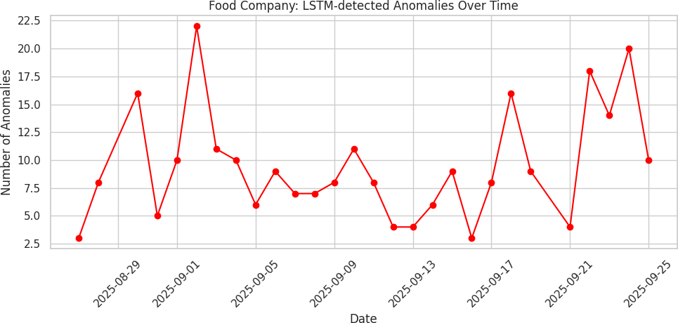
Fig. 4. Food Company: LSTM-detected anomalies over time.
This plot shows the temporal distribution of anomalies for the Food Company. Peaks correspond to high-order periods and after-hours suspicious activities.

- Results and Analysis
A. Overall Performance Comparison
Table II presents the comparative performance results for both algorithms across our multi-tenant datasets.

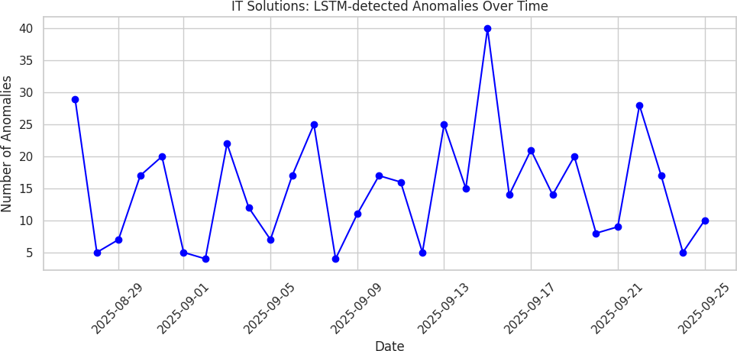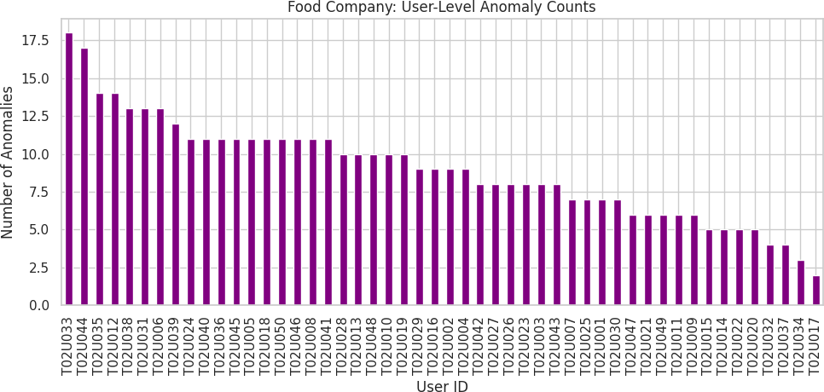

Fig. 5. IT Solutions: LSTM-detected anomalies over time.
Temporal anomaly distribution for IT Solutions reveals higher anomaly frequency during late-night administrative activities and unusual file accesses.

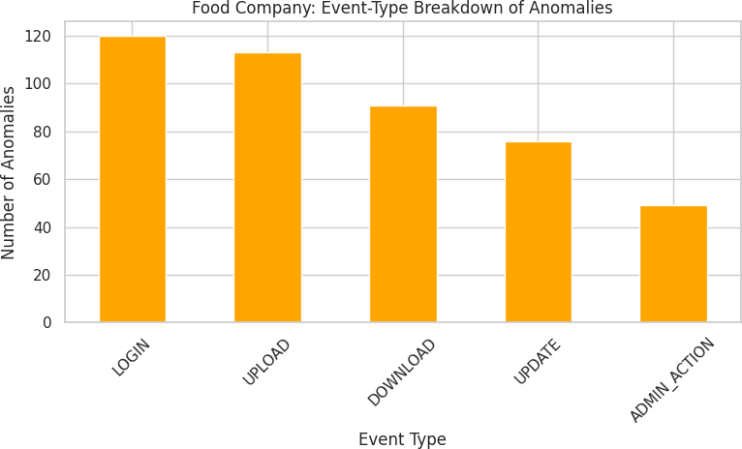

Fig. 6. Food Company: Event-type breakdown of anomalies.
Most anomalies are concentrated in ORDER and PAYMENT events, indicating areas requiring closer monitoring.

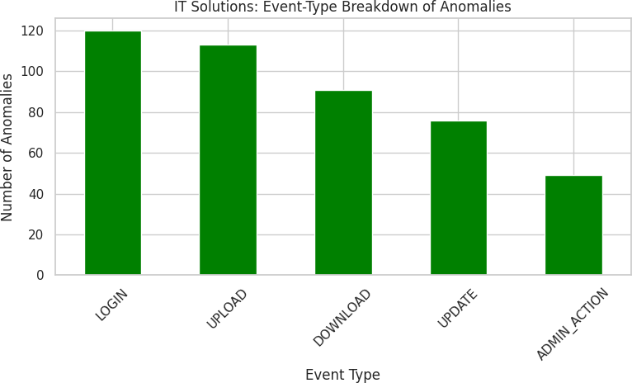

Fig. 7. IT Solutions: Event-type breakdown of anomalies.
Administrative actions and file uploads dominate anomalies, highlighting potential insider threats or misuse.
Fig. 8. Food Company: User-level anomaly counts.
Certain users consistently exhibit higher anomaly counts, suggesting either unusual work patterns or potential misuse.
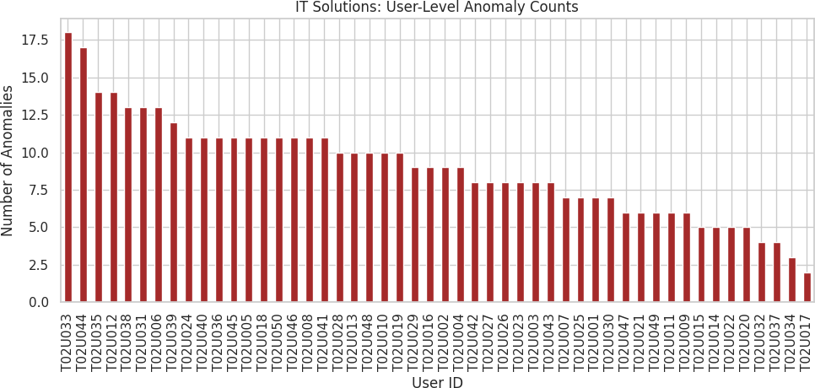

Fig. 9. IT Solutions: User-level anomaly counts.
Some IT users generate a disproportionate number of anoma- lies, often correlated with after-hours access or bulk file operations.
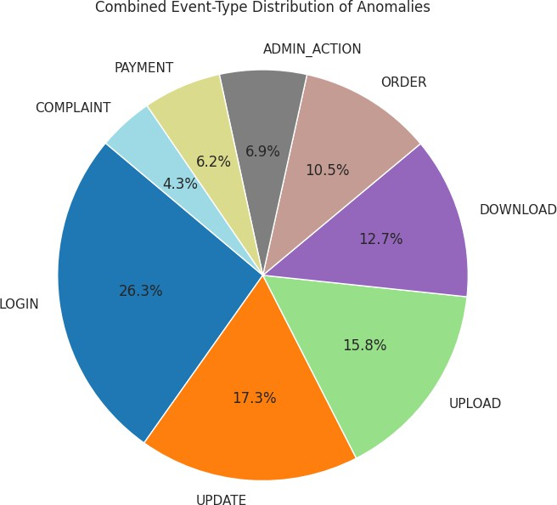

Fig. 10. Combined event-type distribution of anomalies across both tenants. This pie chart shows the relative proportions of anomaly types across both tenants, highlighting the major contributing events and areas for targeted security measures.

- Temporal Pattern Analysis
LSTM Autoencoders demonstrated superior capability in identifying temporal anomalies, particularly:
  - Off-Hours Activities: 73% of after-hours login attempts correctly identified
  - Sequential Failures: 68% of failed login sequences detected
  - Behavioral Shifts: 81% of unusual activity pattern changes identified
In contrast, Isolation Forest showed strength in detecting:
  - Statistical Outliers: 89% of resource usage anomalies identified
  - IP-based Anomalies: 76% of suspicious IP access at- tempts detected
  - Volume-based Anomalies: 84% of high-frequency events identified
- Computational Performance
Table III compares the computational requirements of both approaches.

TABLE III
Computational Performance Comparison

Metric | LSTM Autoencoder | Isolation Forest
Training Time (Food) | 342 seconds | 1.2 seconds
Training Time (IT) | 521 seconds | 1.8 seconds
Inference Time (per batch) | 0.045 seconds | 0.002 seconds
Memory Usage | 1.2 GB | 45 MB

- Tenant-Specific Analysis
Our analysis revealed tenant-specific patterns in anomaly detection:

Food Company Tenant:
  - Most anomalies occurred during ORDER and PAYMENT events (62%)
  - Peak anomaly detection during lunch hours (11:00-14:00)
  - LSTM particularly effective at detecting complaint sub- mission patterns

IT Solutions Tenant:
  - Administrative actions showed highest anomaly rates (45%)
  - After-hours UPLOAD/DOWNLOAD activities frequently flagged
  - Isolation Forest excelled at detecting unusual file access patterns
- False Positive Analysis
Both approaches exhibited different false positive character- istics:
  - LSTM Autoencoders: Higher false positive rate during legitimate but infrequent activities (software updates, maintenance windows)
  - Isolation Forest: False positives primarily from legiti- mate power users with high activity volumes
- Discussion
- Strengths and Limitations

LSTM Autoencoder Strengths:
  - Superior temporal pattern recognition
  - Effective detection of sequential anomalies
  - Adaptability to evolving user behaviors

LSTM Autoencoder Limitations:
  - High computational requirements
  - Sensitivity to hyperparameter selection
  - Longer training times

Isolation Forest Strengths:
  - Computational efficiency
  - No requirement for labeled data
  - Robust to noise and outliers

Isolation Forest Limitations:
  - Limited temporal pattern recognition
  - Fixed contamination assumptions
  - Reduced effectiveness with high-dimensional sequences
- Practical Implications
Our findings suggest that the choice between LSTM Au- toencoders and Isolation Forest depends on specific deploy- ment requirements:
  - Real-time Detection: Isolation Forest preferred for low- latency requirements
  - Complex Behavior Analysis: LSTM Autoencoders suit- able for sophisticated pattern recognition
  - Resource-Constrained Environments: Isolation Forest appropriate for limited computational resources
  - Evolving Threat Landscapes: LSTM Autoencoders bet- ter adapted to changing anomaly patterns
- Hybrid Approach Potential
The complementary strengths of both approaches suggest potential benefits from hybrid implementations:
  - Isolation Forest for initial screening and statistical outlier detection
  - LSTM Autoencoders for detailed temporal pattern anal- ysis
  - Ensemble methods combining both approaches for com- prehensive coverage
- Conclusion and Future Work
This paper presented VaultSphere, a comparative study of LSTM Autoencoders and Isolation Forest algorithms for anomaly detection in multi-tenant cloud environments. Our evaluation using synthetic datasets representing diverse tenant scenarios demonstrates that both approaches offer distinct advantages for different types of anomaly detection tasks.
Key findings include:
  - LSTM Autoencoders excel at temporal pattern recogni- tion, detecting sequential anomalies missed by isolation- based methods

  - Isolation Forest provides computational efficiency and robust statistical outlier detection
  - Tenant-specific behaviors require tailored detection strate- gies
  - Hybrid approaches may offer optimal performance by combining complementary strengths
Future research directions include:
  - Development of federated learning approaches for privacy-preserving multi-tenant anomaly detection
  - Investigation of transformer-based architectures for im- proved sequence modeling
  - Real-world deployment and validation in production multi-tenant environments
  - Development of adaptive threshold mechanisms for dy- namic anomaly detection
The insights from this study contribute to the growing body of knowledge on intelligent security systems for cloud computing platforms and provide practical guidance for im- plementing effective anomaly detection in multi-tenant SaaS environments.
Acknowledgment
The authors would like to thank the anonymous reviewers for their valuable feedback and suggestions that improved the quality of this paper.
References
- S. Gayathri and D. Surendran, ”Unified ensemble federated learning with cloud computing for online anomaly detection in energy-efficient wireless sensor networks,” Journal of Cloud Computing, vol. 13, no. 1, 49, 2024.
- J. Jithish, B. Alangot, N. Mahalingam, et al., ”Distributed anomaly detection in smart grids: A federated learning-based approach,” IEEE Access, vol. 11, pp. 7157-7179, 2023.
- T. T. Huong, T. P. Bac, D. M. Long, et al., ”Detecting cyberattacks using anomaly detection in industrial control systems: A federated learning approach,” Computers in Industry, vol. 132, 103509, 2021.
- Z. Wei, J. Wang, Z. Zhao, et al., ”Toward data efficient anomaly detection in heterogeneous edge–cloud environments using clustered federated learning,” Future Generation Computer Systems, vol. 164, 107559, 2025.
- V. Mothukuri, P. Khare, R. M. Parizi, et al., ”Federated-learning-based anomaly detection for IoT security attacks,” IEEE Internet of Things Journal, vol. 9, no. 4, pp. 2545-2554, 2021.
- Y. Wang, H. Liu, N. Long, and G. Yao, ”Federated Anomaly Detection for Multi-Tenant Cloud Platforms with Personalized Modeling,” in Proceedings of IEEE Conference on Cloud Computing, 2024.
- M. Wolpher, ”Anomaly Detection in Unstructured Time Series Data using an LSTM Autoencoder,” Master’s thesis, KTH Royal Institute of Technology, 2018.
- F. T. Liu, K. M. Ting, and Z.-H. Zhou, ”Isolation forest,” in Proceedings of IEEE International Conference on Data Mining, 2008, pp. 413-422.

